**Bugle School**

Aspire Academy Trust

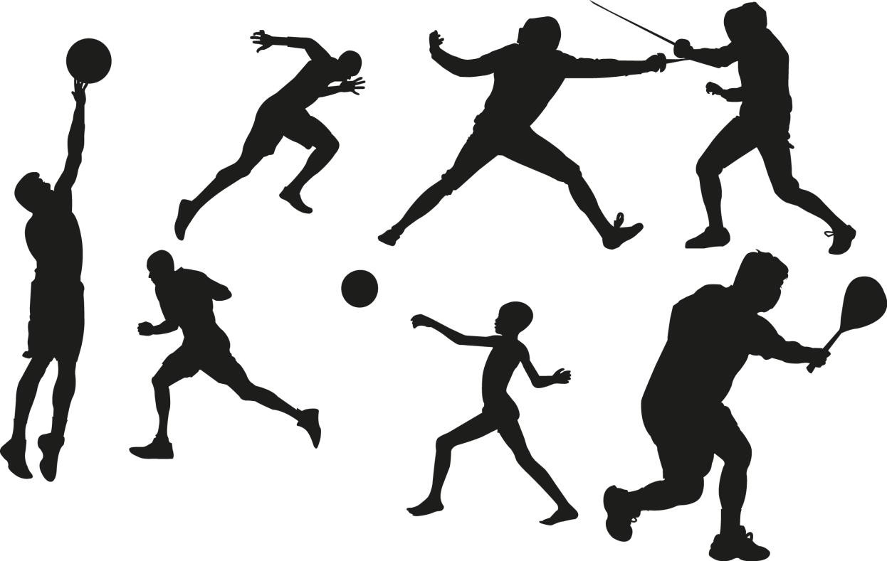

PE Curriculum

The PE curriculum at Bugle School is made up of 2 key components.

1. Children’s development of Physical Literacy. This is the children’s ability to move, play and develop the core skills required to develop and progress in different sports and team games. It is centered around 6 key cogs of learning. These are the main drivers behind every session. Every Real PE session follows the following format: Warm up, Learn Skill, Application, Cool Down and Review. During the new learning, skills have clear progressions of challenge. All children are encouraged to develop resilience to the new challenge, but also understand that they can compete against their own personal best.
2. Part two of the curriculum, is the application of the key skills. Once children have developed the fundamental movements, we need to ensure that they are exposed to a range of team and individual sports and competitions. After school clubs, inter school competitions and external matches will provide the children with the opportunity to compete.

Below outlines the progression in learning for Parts 1 and 2.

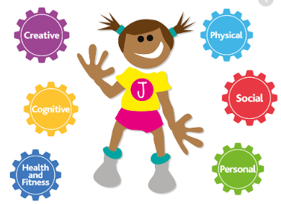

**EYFS and KS1**

|  |  |  |  |
| --- | --- | --- | --- |
| **Cog focus** | **Reception class** | **Year 1** | **Year 2** |
| **Personal** | Weeks 1-3 – Coordination and Footwork **(FUNS Station 10)**  Weeks 4-6 Static balance – One leg. **(FUNS Station 1)** | Weeks 1-3 – Coordination and Footwork **(FUNS Station 10)**  Weeks 4-6 Static balance – One leg. **(FUNS Station 1)** | Weeks 1-3 – Coordination and Footwork **(FUNS Station 10)**  Weeks 4-6 Static balance – One leg. **(FUNS Station 1)** |
| **Social** | Weeks 7-9 – Dynamic Balance to agility: Jumping and landing  **(FUNS Station 6)**  Weeks 10-12 – static balance Seated **(FUNS Station 2)** | Weeks 7-9 – Dynamic Balance to agility: Jumping and landing  **(FUNS Station 6)**  Weeks 10-12 – static balance Seated **(FUNS Station 2)** | Weeks 7-9 – Dynamic Balance to agility: Jumping and landing  **(FUNS Station 6)**  Weeks 10-12 – static balance Seated **(FUNS Station 2)** |
| **Cognitive** | Weeks 13-15 Dynamic balance on a line.  **(FUNS Station 5)**  Weeks 16-18 – Static balance – Stance  **(FUNS Station 4)** | Weeks 13-15 Dynamic balance on a line.  **(FUNS Station 5)**  Weeks 16-18 – Static balance – Stance  **(FUNS Station 4)** | Weeks 13-15 Dynamic balance on a line.  **(FUNS Station 5)**  Weeks 16-18 – Static balance – Stance  **(FUNS Station 4)** |
| **Creative** | Weeks 19-21 – Coordination – Ball Skills  **(FUNS Station 9)**  Weeks 22-24 – Counter balance – with a partner  **(FUNS Station 7)** | Weeks 19-21 – Coordination – Ball Skills  **(FUNS Station 9)**  Weeks 22-24 – Counter balance – with a partner  **(FUNS Station 7)** | Weeks 19-21 – Coordination – Ball Skills  **(FUNS Station 9)**  Weeks 22-24 – Counter balance – with a partner  **(FUNS Station 7)** |
| **Applying Physical** | Weeks 25-27 – coordination – sending and receiving  **(FUNS Station 8)**  Weeks 28-30 – Agility – reaction and response.  **(FUNS Station 12)** | Weeks 25-27 – coordination – sending and receiving  **(FUNS Station 8)**  Weeks 28-30 – Agility – reaction and response.  **(FUNS Station 12)** | Weeks 25-27 – coordination – sending and receiving  **(FUNS Station 8)**  Weeks 28-30 – Agility – reaction and response.  **(FUNS Station 12)** |
| **Health and Fitness** | Week 31-33 – Agility – ball chasing  **(FUNS Station 11)**  Week 34-36 – Static balance – floor work.  **(FUNS Station 3)** | Week 31-33 – Agility – ball chasing  **(FUNS Station 11)**  Week 34-36 – Static balance – floor work.  **(FUNS Station 3)** | Week 31-33 – Agility – ball chasing  **(FUNS Station 11)**  Week 34-36 – Static balance – floor work.  **(FUNS Station 3)** |

**Key Stage 2**

|  |  |  |  |
| --- | --- | --- | --- |
| **Cog focus** | **Year 3** | **Year 4** | **Year 5/6** |
| **Personal** | Weeks 1-6 – Skill: Coordination: Footwork **(FUNS Station 10)**  Cool down: Static balance – One leg. **(FUNS Station 1)** | Weeks 1-6 – Skill: Coordination: Footwork **(FUNS Station 10)**  Cool down: Static balance – One leg. **(FUNS Station 1)** | Weeks 1-6 – Coordination: ball skills **(FUNS Station 9)**  Agility: reaction/response  **(FUNS Station 12)** |
| **Social** | Weeks 7-12 – Skill: Dynamic Balance to agility: Jumping and landing  **(FUNS Station 6)**  Cool down – static balance Seated **(FUNS Station 2)** | Weeks 7-12 – Skill: Dynamic Balance to agility: Jumping and landing  **(FUNS Station 6)**  Cool down – static balance Seated **(FUNS Station 2)** | Weeks 7-12 – static balance: seated  **(FUNS Station 2)**  Static Floor Work **(FUNS Station 3)** |
| **Cognitive** | Weeks 13-18: Skill: Dynamic balance on a line.  **(FUNS Station 5)**  Cool down – Coordination ball skills  **(FUNS Station 9)** | Weeks 13-18: Skill: Dynamic balance on a line.  **(FUNS Station 5)**  Cool down – Coordination ball skills  **(FUNS Station 9)** | Weeks 13-18 Dynamic balance on a line.  **(FUNS Station 5)**  Counter balance with a partner  **(FUNS Station 7)** |
| **Creative** | Weeks 19-24 – Skill: Coordination – sending and receiving  **(FUNS Station 8)**  Cool down – Counter balance with a partner  **(FUNS Station 7)** | Weeks 19-24 – Skill: Coordination – sending and receiving  **(FUNS Station 8)**  Cool down – Counter balance with a partner  **(FUNS Station 7)** | Weeks 19-24 – Static balance: One leg  **(FUNS Station 1)**  Dynamic Balance to Agility: jumping and landing  **(FUNS Station 6)** |
| **Applying Physical** | Weeks 25-30 – Agility: reaction/response  **(FUNS Station 12)**  Cool down – static balance floor work  **(FUNS Station 3)** | Weeks 25-30 – Agility: reaction/response  **(FUNS Station 12)**  Cool down – static balance floor work  **(FUNS Station 3)** | Weeks 25-30 – static balance: stance  **(FUNS Station 4)**  Coordination: footwork  **(FUNS Station 10)** |
| **Health and Fitness** | Week 31-36 – Skill – Agility: ball chasing  **(FUNS Station 11)**  Cool down – Static balance – stance  **(FUNS Station 4)** | Week 31-36 – Skill – Agility: ball chasing  **(FUNS Station 11)**  Cool down – Static balance – stance  **(FUNS Station 4)** | Week 31-33 – Agility – ball chasing  **(FUNS Station 11)**  Coordination – sending and receiving  **(FUNS Station 8)** |

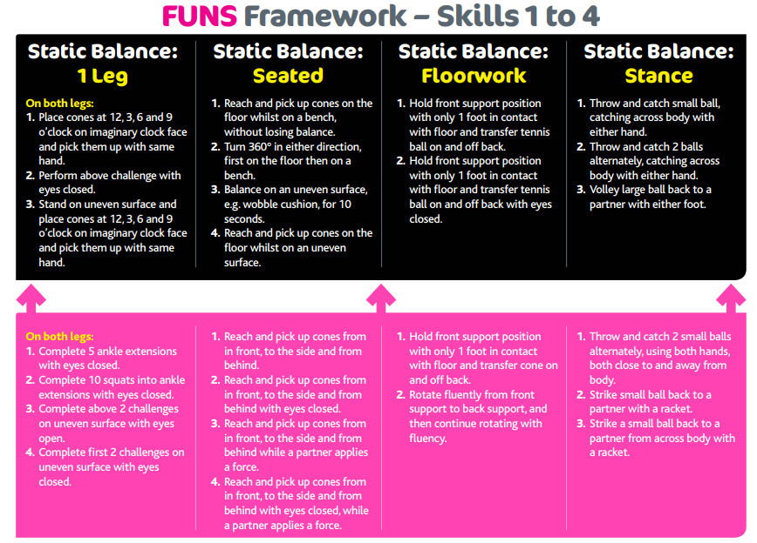

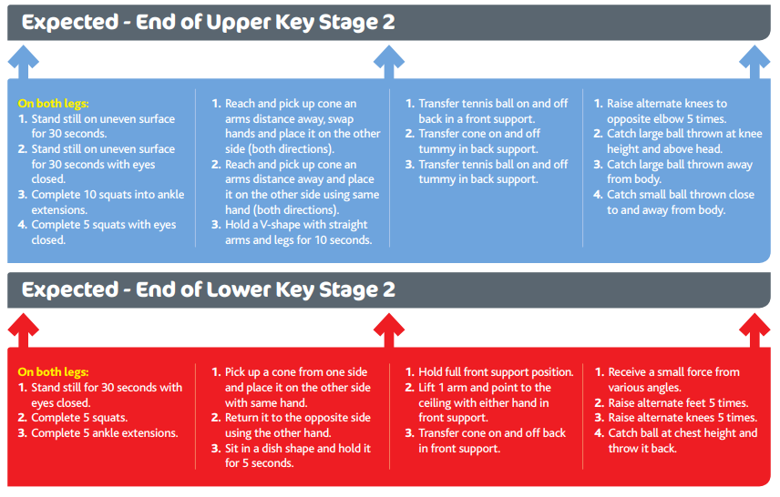

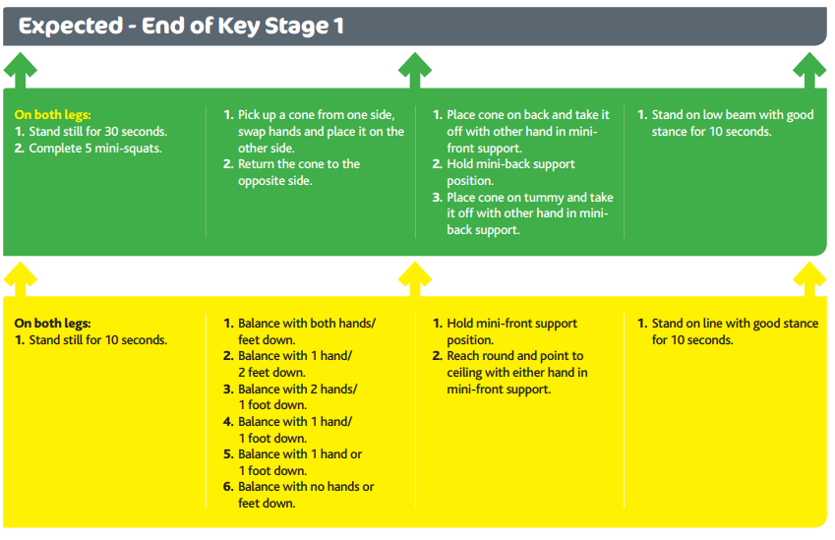

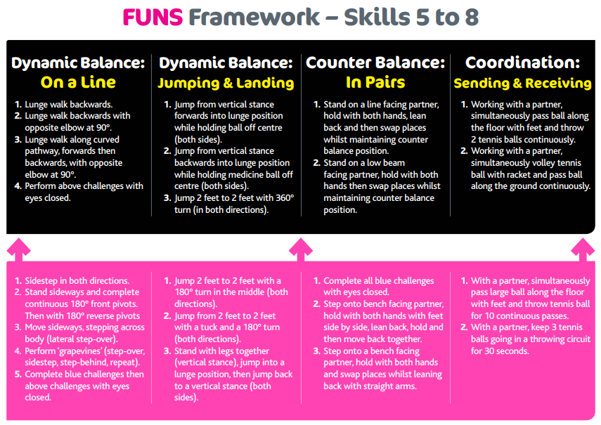

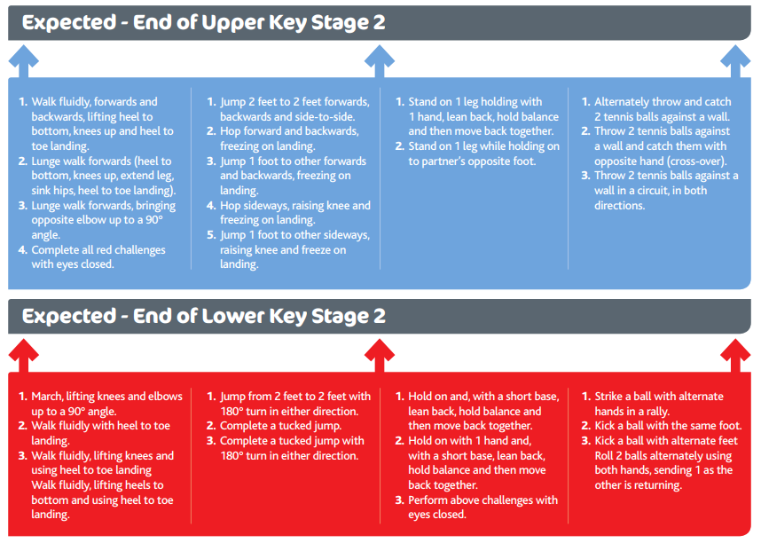

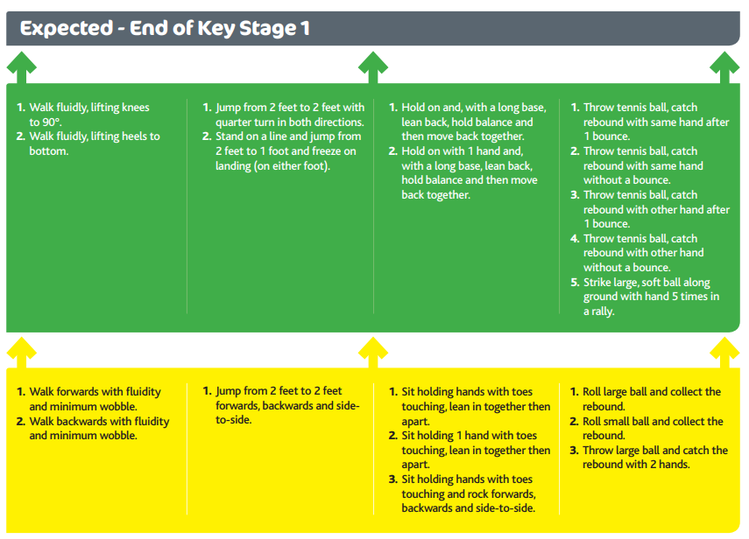

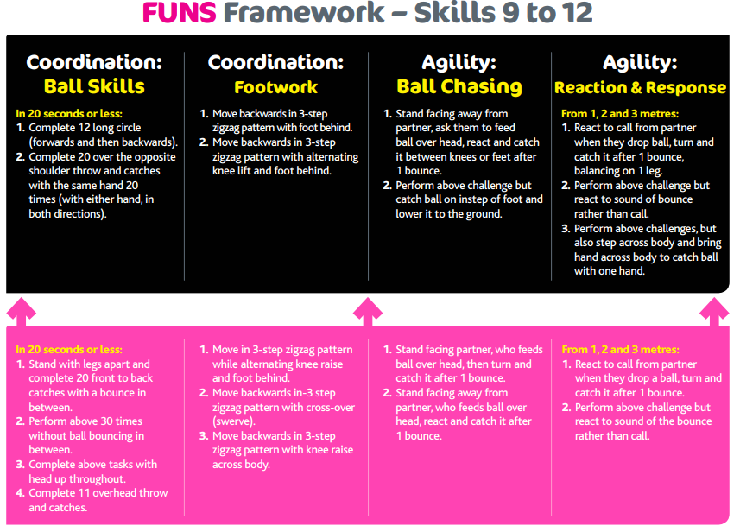

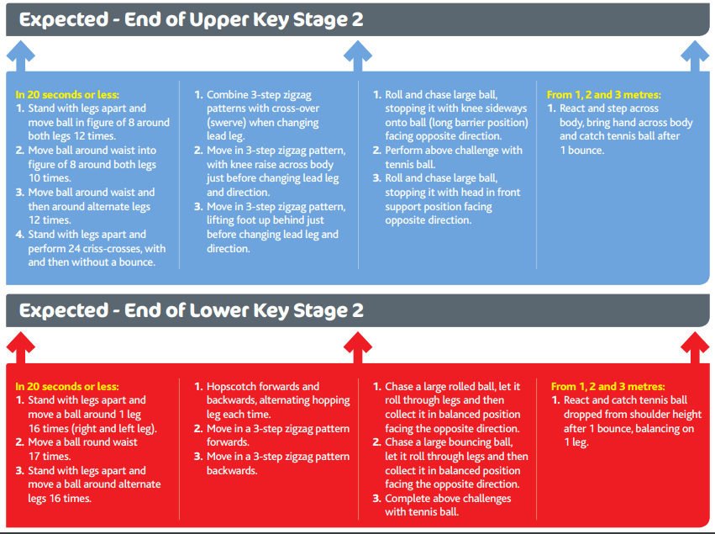

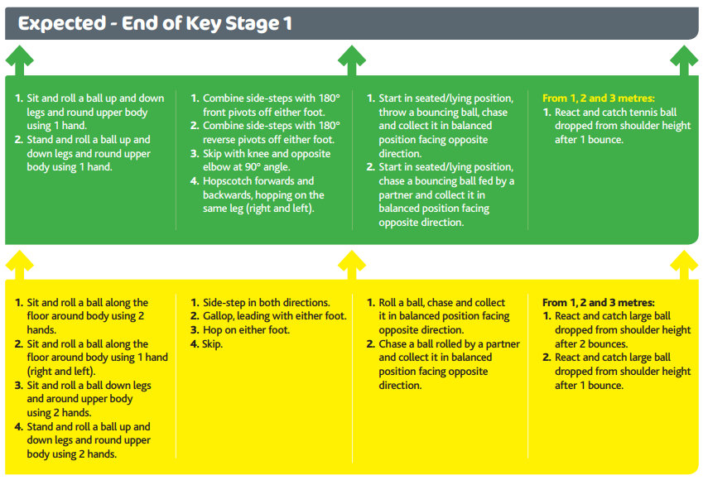

PE Overview

**Autumn Term Spring Term Summer Term**

Sport Focus Sport Focus Sport Focus

**Autumn 1 Autumn 2 Spring 1 Spring 2 Summer 1 Summer 2**

**Year**

**1**

**Year**

**2**

**Multiskills Throwing and catching**

**Multiskills Throwing and catching**

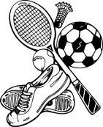

**Dance Gymnastics Football Athletics**

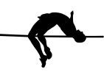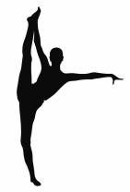

**Dance Gymnastics Football Athletics**

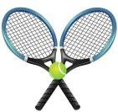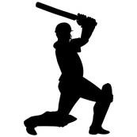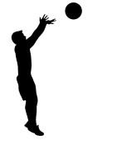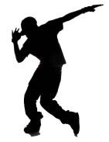

**Year**



**3**

**Year**

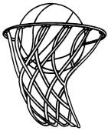

**4**

**Year**

**5**

**Year**

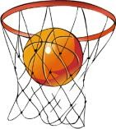

**6**



**Swimming Swimming Dance Hockey Tennis Athletics Swimming Swimming Netball Gymnastics Rounders Athletics Hockey Basketball Dance Gymnastics Cricket Athletics**

**Tag Rugby Handball Gymnastics Dance Cricket Athletics**



Year 1

**Autumn Term**

**Autumn 1 Autumn 2**

**Multiskills Throwing and catching**

**Overview**

*Move fluently, changing speed and direction easily and avoiding collisions*

*Develop control and accuracy when rolling a ball Develop control and accuracy when throwing underarm Develop control and accuracy when striking a ball*

***Developing Skills***

***Developing Skills***

*Understand the concept of tracking, getting in line with a ball to receive it*

*Move fluently, changing speed and direction easily and avoiding collisions*

*Develop control and accuracy when rolling a ball Develop control and accuracy when throwing underarm Develop control and accuracy when striking a ball Develop control and accuracy when kicking a ball*

*Understand the concept of tracking, getting in line with a ball to receive it*

**Suggested**

***Applying and Linking Skills***

**Content**

*Choose and use skills effectively for practical games*

*Choose and use skills effectively for practical games*

***Applying and Linking Skills***

*Copy, watch and describe what others are doing*

***Evaluating Success***

***Evaluating Success***

*Copy what is seen and state why it is of quality*

*Copy, watch and describe what others are doing*

*Copy what is seen and state why it is of quality*

**Required**

**Resources**

Footballs size 3 or 4 (x15) Bibbs

Cones

Small goals x4

Tennis rackets

Tennis Balls

Footballs size 3 or 4 (x15) Bibbs

Cones

Small goals x4

Tennis rackets

Tennis Balls



**Location** *KS1 Playground KS1 Playground*

Year 1

**Spring Term**

**Spring 1 Spring 1**

**Dance Gymnastics**

**Overview**

*Copy and explore basic body actions (e.g. travel, jump, turn, gesture)*

***Developing Skills***

*Sequencing*

*Respond to a range of stimuli with different actions Use different parts of the body to respond to stimuli Copy movement and movement patterns*

*Travel in different directions and at different levels*

*Perform a gymnastic sequence with a balance, a travelling action, a jump and a roll*

*Explore the 5 basic shapes:*

*straight/tucked/star/straddle/pike*

*Develop arch and dish shapes that see arms and legs extended off the floor*

*Balance*

*Develop tension in the core and tension and extension in the arms, legs, hands and feet*

**Suggested**

***Applying and Linking Skills***

**Content**

*Compose and link movement phrases to make simple dances with a clear beginning, middle and end*

*Perform movement phrases using a range of body actions and body parts*

*Travel*

*Pike, tuck, arch and dish shapes*

*Taking weight on hands and feet*

*Monkey walk*

*Caterpillar walk*

*Bunny hop*

*Jump*

*Explore shapes in the air when jumping*

*Watch and talk about different dances Explain how dances make us feel Describe qualities of movement*

***Evaluating Success***

*Roll*

*Pencil roll*

*Egg roll*

*Dish Roll*

**Required**

**Resources**

*Sound system*

*Related music*

*Benches x5*

*Mats x15*

*Hoops x15*



**Location** *Dining Hall Top Hall*

Year 1

**Summer Term**

***Running***

**Summer 1 Summer 2**

**Football Athletics**

**Overview**

*Run a flat sprint*

*Run a spring using hurdles*

*Dribble the ball in different directions*

*Stop the ball using a stated part of the body*

**Suggested**

**Content**

*Maintain control over the ball when dribbling Pass the ball accurately to a partner Control a pass when sent by a partner Strike the ball towards a target*

*Block or catch a shot towards goal*

*Tackle an opponent when they are dribbling*

***Throwing***

*Jump from a stationary position*

***Jumping***

*Jump upwards*

*Throw bean bags to a set target*

**Required**

**Resources**

Footballs size 3 or 4 (x15) Bibbs

Cones

Small goals x4

Bean bags x15

Hoops Hurdles Javelins x25



**Location** *KS1 Playground KS1 Playground*

Year 2

**Autumn Term**

**Autumn 1 Autumn 1**

**Multiskills Throwing and catching**

**Overview**

*Perform a range of rolling, throwing, striking, kicking, catching and gathering skills with control*

*Develop an awareness of others in running, chasing and avoiding games*

*Make simple decisions about when and where to run*

***Developing Skills***

***Developing Skills***

*Practise accuracy in throwing and hitting skills*

*Perform a range of rolling, throwing, striking, kicking, catching and gathering skills with control*

*Develop an awareness of others in running, chasing and avoiding games*

*Make simple decisions about when and where to run*

*Practise accuracy in throwing and hitting skills*

**Suggested**

***Applying and Linking Skills***

**Content**

*Choose and use skills effectively for practical games*

*Choose and use skills effectively for practical games*

***Applying and Linking Skills***

*Copy, watch and describe what others are doing*

***Evaluating Success***

*Copy what is seen and state why it is of quality*

*Copy, watch and describe what others are doing*

*Copy what is seen and state why it is of quality*

***Evaluating Success***

**Required**

**Resources**

Footballs size 3 or 4 (x15) Bibbs

Cones

Small goals x4

Tennis rackets

Tennis Balls

Bean bags x15

Hoops Hurdles Javelins x25



**Location** *KS1 Playground KS1 Playground*

Year 2

**Spring Term**

**Spring 1 Spring 1**

**Dance Gymnastics**

**Overview**

*Repeat a range of actions with co-ordination and control Link a range of actions with coordination and control Explore actions in response to stimuli*

***Developing Skills***

*Sequencing*

*Development movement of the body to express emotions*

*Devise a short sequence with a clear beginning, middle and an end including a balance, a travelling action, a jump and a roll*

*Adapt a sequence to include apparatus*

*Teach a self-created sequence to a partner and perform together*

*Explore the 5 basic shapes:*

*straight/tucked/star/straddle/pike*

*Develop arch and dish shapes that see arms and legs extended off the floor*

*Balance*

**Suggested**

**Content**

*Choose and link actions that express a mod, idea or feeling with rhythmic and dynamic qualities*

***Applying and Linking Skills***

*Remember and repeat a short dance phrase*

*Perform dance phrases and short dances using rhythmic and dynamic qualities that express moods, ideas and feelings*

*Travel*

*Show greater control, coordination and spatial awareness*

*Develop tension in the core and tension and extension in the arms, legs, hands and feet*

*Pike, tuck, arch and dish shapes*

*Taking weight on hands and feet*

*Monkey walk, Caterpillar walk, Bunny hop*

*Move smoothly from a position of stillness to a travelling movement and from one position of stillness to another*

*Jump*

*Talk about how a dance could be improved*

*Describe and evaluate some of the compositional features.*

*of dances performed with a partner and in a group. Understand how a dance is formed and performed.*

***Evaluating Success***

*Roll*

*Evaluate, refine and develop their own and others' work.*

*Explore shapes in the air when jumping*

*Pencil roll Egg roll Dish Roll*

*Beginnings of forward roll*

**Required**

**Resources**

*Sound system*

*Related music*

*Benches x5*

*Mats x15*

*Increasing height of gymnastics equipment*



**Location** *Dining Hall Top Hall*

Year 2

**Summer Term**

***Running***

**Summer 1 Summer 1**

**Football Athletics**

**Overview**

*Run a flat sprint*

*Run a spring using hurdles*

*Dribble the ball in different directions*

*Stop the ball using a stated part of the body*

*Maintain control over the ball when dribbling*

**Suggested**

**Content**

*Pass the ball accurately to a partner Control a pass when sent by a partner Pass the ball with either foot to a partner*

*Strike the ball off the ground towards a target*

*Block or catch a shot towards goal*

*Tackle an opponent when they are dribbling*

*Develop use of arms and body shape to increase distance and height of jumps*

***Jumping***

*Maximise the distance a tennis ball can be thrown*

***Throwing***

*Throw bean bags at a set target*

**Required**

**Resources**

Footballs size 3 or 4 (x15) Bibbs

Cones

Small goals x4

Bean bags x15

Hoops Hurdles Measuring tape Tennis Balls



**Location** *KS1 Playground KS1 Playground*

Year 3

**Autumn Term**

**Autumn 1 Autumn 1**

**Swimming Swimming**

**Overview**

***Content taught by swimming coach at Polkyth***

***Sports Centre***

***Content taught by swimming coach at Polkyth***

***Sports Centre***

*Develop basic pool safety skills and confidence in water*

*Develop basic pool safety skills and confidence in water*

*Develop travel in vertical and horizonal position and introduce floats*

*Develop travel in vertical and horizonal position and introduce floats*

**Suggested**

**Content**

*Develop push and glides, any kick action on front and back with or without support aids*

*Develop entry and exit, travel further, float and submerge*

*Develop push and glides, any kick action on front and back with or without support aids*

*Develop entry and exit, travel further, float and submerge*

*Develop balance, link activities and travel further on whole stroke.*

*Develop balance, link activities and travel further on whole stroke.*

*Show breath control*

*Show breath control*

*Tread water*

*Tread water*

*To choose, use and vary strokes and skills, according to the task and the challenge*

*To choose, use and vary strokes and skills, according to the task and the challenge*

**Required**

**Resource**

*Polkyth Pool Polkyth Pool*



Year 3

**Spring Term**

**Spring 1 Spring 1**

**Dance (Suggested: Bollywood) Hockey**

**Overview**

*Create dance phrases to communicate an idea*

*Develop movement using actions, space, relationships and dynamics*

***Developing Skills***

*Understand choreographic devices such as motif, a repetition*

*Develop a sense of musicality in movements*

*Introduce mirroring, unison, canon, complementary and contrasting moves*

*Understanding the parts of the stick*

*Developing the hockey stance*

**Suggested**

**Content**

*Connect different ideas to structure a dance phrase*

***Applying and Linking Skills***

*Link phrases to music*

*Showcase a clear beginning, middle and end*

*Dribble the ball using the* ***open side*** *of the stick with control and accuracy*

*Send and receive the ball using a* ***push pass*** *with control and accuracy*

*Strike the ball accurately into a target area using the* ***push shot*** *with control and accuracy whilst under pressure from opponents*

*Strike the ball accurately into a target area using the* ***slap shot*** *with control and accuracy whilst under pressure from opponents*

*Describe and evaluate compositional features of dances performed with a partner and in a group*

***Evaluating Success***

*Talk about how to improve a dance*

**Required**

**Resources**

*Sound system*

*Related music*

*30 hockey sticks*

*30 hockey balls*

*Cones*

*Bibs*

*Pop-up goals*



**Location** *Top Hall Ball Court*

Year 3

**Summer Term**

**Summer 1 Summer 2**

**Tennis Athletics**

**Overview**

*Develop a running stride when running a flat sprint*

***Running***

*Strike the ball into a set area Strike a fast moving ball into a set area Hit the ball on the volley into a set area*

*Strike a bouncing ball into a set area*

*Run a spring using hurdles*

*Begin to run lengthier distances*

**Suggested**

**Content**

*Strike a ball moving towards you into a set area Develop striking the ball on the backhand Serve underarm to an opponent*

*Serve overarm to an opponent*

*Develop team skills when playing in doubles against an opponent*

*Perform combinations of jumps e.g. hop, step, jump showing control and consistency*

*Choose different styles of jumping*

***Jumping***

*Throw a javelin from a standing position*

*Maximise the distance a tennis ball can be thrown*

***Throwing***

*Throw bean bags at a set target*

**Required**

**Resources**

*Bucket of tennis balls*

*Tennis rackets x30*

*Tennis nets x5*

Bean bags x15

Hoops Hurdles Measuring tape Tennis Balls Foam Javelins



**Location** *KS2 Playground KS2 Playground*

Year 4

**Autumn Term**

**Autumn 1 Autumn 1**

**Swimming Swimming**

**Overview**

***Content taught by swimming coach at Polkyth***

***Sports Centre***

***Content taught by swimming coach at Polkyth***

***Sports Centre***

*Develop basic pool safety skills and confidence in water*

*Develop basic pool safety skills and confidence in water*

*Develop travel in vertical and horizonal position and introduce floats*

*Develop travel in vertical and horizonal position and introduce floats*

**Suggested**

**Content**

*Develop push and glides, any kick action on front and back with or without support aids*

*Develop entry and exit, travel further, float and submerge*

*Develop push and glides, any kick action on front and back with or without support aids*

*Develop entry and exit, travel further, float and submerge*

*Develop balance, link activities and travel further on whole stroke.*

*Develop balance, link activities and travel further on whole stroke.*

*Show breath control*

*Show breath control*

*Tread water*

*Tread water*

*To choose, use and vary strokes and skills, according to the task and the challenge*

*To choose, use and vary strokes and skills, according to the task and the challenge*

**Required**

*Polkyth Pool Polkyth Pool*



Year 4

**Spring Term**

**Spring 1 Spring 1**

**Netball Gymnastics**

**Overview**

*Link 3 different balances with 3 different ways of travelling showing clear changes of speed.*

*Sequencing*

*Create a sequence containing four elements travelling in an “L” shaped*

*pathway*

*Explore balancing on combinations of 1/2/3/4 “points”*

*Pass to teammates using a chest pass Pass to teammates using a bounce pass Pass to teammates using a shoulder pass*

*Send and receive the ball to and from a teammate on the move whilst under pressure from opponents*

*Travel*

*Balance on floor and apparatus exploring which body parts are the safest to use.*

*Balance*

*Explore balancing with a partner: facing, beside, behind and on different levels.*

*Move in and out of balance fluently.*

*Bunny hop*

*Use a variety of rolling actions to travel on the floor and along apparatus.*

*Travel with a partner; move away from and together on the floor and on apparatus.*

**Suggested**

**Content**

*Develop the skill of shooting into a hoop*

*Shoot into a hoop whilst under pressure from an opponent*

*Create space on the pitch to receive a pass from a teammate*

*Jump*

*Pivot to change facing direction when holding the ball*

*Defending; picking an opponent, based on position and sticking with them*

*Travel at different speeds*

*Travel in different pathways on the floor and using apparatus, explore different entry and exit points other than travelling in a straight line on apparatus.*

*Demonstrate control of straight, star and tucked shapes, perform from a bench – stress keeping body upright, strong core, tension and extension in limbs.*

*Stag Jump (on floor into apparatus)*

*Quarter or half term jumps (on floor into apparatus)*

*Continue to develop control in the Pencil, Dish, Teddy Bear & Rock and Roll rolling actions on the floor, off and along apparatus or in time with a partner.*

*Combine the phases of earlier rolling actions to perform the full forward roll.*

*Roll*

*Backward rolls*

**Required**

**Resources**

*15 netballs*

*4 netball hoops*

*Bibs*

*Cones*

*Benches x5*

*Mats x15*

*Increasing height of gymnastics equipment*



**Location** *Ball Court Top Hall*

Year 4

**Summer Term**

**Summer 1 Summer 2**

**Rounders Athletics**

**Overview**

*Improve reaction times when running a flat sprint*

***Running***

*Throw the ball overarm to a designated base*

*Consistently catch the ball at various heights and speeds*

*Gather a bouncing ball*

*Run a spring using hurdles*

*Run a relay*

*Develop pacing when distance running*

**Suggested**

**Content**

*Move and gather a ball travelling low to the ground*

*Bowl underarm to a set height to a batter Bowl at pace underarm to a batter Run at pace between bases*

***Jumping***

*Strike the ball*

*Strike the ball in a chosen direction away from a set field*

***Throwing***

*Perform combinations of jumps e.g. hop, step, jump showing control and consistency*

*Choose different styles of jumping*

*Develop a run up when jumping for distance*

*Throw a shot put from a static position*

*Throw a javelin from a standing position*

*Maximise the distance a tennis ball can be thrown*

*Throw bean bags at a set target*

**Required**

**Resources**

*Rounders bats x10*

*Tennis balls Cones Bibbs*

Bean bags x15

Hoops Hurdles Measuring tape Tennis Balls Foam Javelins Shot Puts



**Location** *KS2 Playground KS2 Playground*

Year 5

**Autumn Term**

**Autumn 1 Autumn 2**

**Hockey Basketball**

**Overview**

*Understanding the parts of the stick*

*Developing the hockey stance*

*Dribble the ball using the* ***open side*** *of the stick with control and accuracy whilst under pressure from opponents*

*Dribble the ball using the* ***open and reverse side*** *of the stick with control and accuracy whilst under pressure from opponents*

*Drivbble in various directions with accuracy and control*

*Dribble in various directions whilst under pressure from opponents*

*Pass to teammates using a chest pass*

*Pass to teammates using a bounce pass*

**Suggested**

**Content**

*Send and receive the ball using a* ***push pass*** *with control and accuracy whilst under pressure from opponents*

*Send and receive the ball using a* ***sweep pass*** *with control and accuracy whilst under pressure from opponents*

*Strike the ball accurately into a target area using the* ***push shot*** *with control and accuracy whilst under pressure from opponents*

*Strike the ball accurately into a target area using the* ***slap shot*** *with control and accuracy whilst under pressure from opponents*

*Send and receive the ball to and from a teammate on the move whilst under pressure from opponents*

*Develop the skill of shooting into a net*

*Shoot into a net whilst under pressure from an opponent*

*Create space on the pitch to receive a pass from a teammate*

*Pivot to change facing direction when holding the ball*

*Use the correct stance to defend against an opponent*

**Required**

**Resources**

*30 hockey sticks*

*30 hockey balls*

*Cones*

*Bibs*

*Pop-up goals*

*15 basketballs*

*Bibs*

*Cones*

*Basketball hoops*



**Location** *Ball Court Ball Court*

Year 5

**Spring Term**

**Spring 1 Spring 1**

**Dance (Suggested: Contemporary) Gymnastics**

**Overview**

*explore, improvise and choose appropriate material to create new motifs in a chosen dance style*

***Developing Skills***

***Sequencing***

*Perform specific skills and movement patterns for different dance styles with accuracy*

*Develop mirroring, unison, canon, complementary and contrasting moves*

*Create a sequence of up to eight elements including asymmetrical shapes, balances and symmetrical rolling and jumping activities. Ensure the sequence includes changes of direction and level and show mirroring and matching shapes and balances.*

*Perform balances with control, showing good body tension.*

*Mirror and match partner’s balance*

*Explore symmetrical and asymmetrical balances on own and with a partner.*

***Balance***

*Explore and develop control in taking some of a partner’s weight*

*using counter balance (pushing against) and counter tension*

*(pulling away from).*

**Suggested**

***Applying and Linking Skills***

**Content**

*Compose dances by using, adapting and developing steps, formations and patterning from different dance styles*

*Perform dances expressively, using a range of performance skills*

*Perform a range of acrobatic balances with a partner on the floor and on different levels on apparatus.*

*Perform group balances at the beginning, middle or end of a sequence.*

*Travel sideways in a bunny hop action*

*Increase the variety of pathways, levels and speeds at which you travel.*

***Travel***

*Travel in time with a partner, move away from and back to a partner.*

*Talk about how they might improve their dances. Describe and evaluate some of the compositional*

***Jump***

***Evaluating Success***

*features of dances performed with a partner and in a group.*

*Understand how a dance is formed and performed. Evaluate, refine and develop their own and others' work.*

***Roll***

*Make symmetrical and asymmetrical shapes in the air.*

*Jump along and off apparatus of varying height with control in the air and on landing.*

*Explore different starting and finishing positions when rolling*

*Complete a forward roll from a straddle position on feet and end in a straddle position on floor or feet*

*Explore symmetry and asymmetry throughout the rolling actions*

**Required**

**Resources**

*Sound system*

*Related music*

*Benches x5*

*Mats x15*

*Increasing height of gymnastics equipment*

*Horse*



**Location** *Dining Hall Top Hall*

Year 5

**Summer Term**

**Summer 1 Summer 2**

**Cricket Athletics**

**Overview**

*Consistently strike a ball towards a target area*

***Batting***

***Running***

*Place shots away from fielders*

*Use defensive shots to defend the stumps*

*Develop strategies for running on a bend Develop the ability to lean towards the line Run a spring using hurdles*

*Run a relay using a baton*

*Develop strategies for a 1km race*

*Consistently catch the ball at various heights and speeds*

**Suggested**

***Fielding***

**Content**

*Gather a bouncing ball*

*Move and gather a ball travelling low to the ground*

***Jumping***

*Throw the ball accurately to a wicket keeper*

*Throw the ball accurately directly at the stumps*

*Demonstrate a range of jumps showing power and control and consistency at both take-off and landing*

*Develop a stride pattern and foot placement when jumping for distance*

*Bowl the ball in a straight line at speed*

***Bowling***

***Throwing***

*When bowling consider where the ball will bounce for the batter*

*Throw a discuss from a standing position*

*Throw a shot put using rotation to develop distance*

*Throw a javelin using a run up*

*Maximise the distance a tennis ball can be thrown*

**Required**

**Resources**

*Quick- cricket set x4*

*Cones*

*Bibbs*

*Plastic balls x10*

Bean bags x15

Hoops Hurdles Measuring tape Tennis Balls

Foam Javelins Shot Puts Batons Discuss Stopwatches

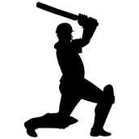

**Location** *KS2 Playground KS2 Playground*

Year 6

**Autumn Term**

**Autumn 1 Autumn 2**

**Tag Rugby Handball**

**Overview**

**Suggested**

**Content**

*Demonstrate good ball handling skills when moving with the ball*

*Pass and receive the ball (pop pass) Pass and receive the ball (standard pass)*

*Pass and receive the ball on the move while under pressure from opponents*

*Complete multiple passes as a team to move forward up the pitch*

*Evade opponents and retain the tag*

*use the correct stance for tackling opponents and ripping off tags*

*Running into space, whilst remaining onside*

*Develop a range of passing techniques becoming familiar with the ball*

*Catch the ball using the “W” shape*

*Pass within a team moving towards a target*

*Pass consistently and accurately whilst under pressure from an opponent*

*Utilise the overhead and popping passes*

*Develop shooting skills including wrist flick and feint shots*

*Develop movement taking a maximum of three steps*

*Develop strategies for intercepting a pass*

*Develop strategies for goal keeping against a handball shot*

**Required**

**Resources**

*Tags*

*Rugby balls x15*

*Bibbs*

*Cones*

*Bounce nets (x3)*

*Handballs x 15*

*Bibs*

*Cones*

*Small Goals*



**Location** *Ball Court Ball Court*

Year 6

**Spring Term**

**Spring 1 Spring 1**

**Gymnastics Dance (Suggested: Hip hop/break dance)**

**Overview**

*Work in a group of 4 to 6 people to create a longer more complex sequence of up to 10 elements. Your sequence may include: e.g. a combination of counter balance/counter tension, twisting/turning, travelling on hands and feet, as well as jumping and rolling. Your sequence should demonstrate different ways of working with a partner or within your group e.g. starting together/apart, moving apart/together, matching/mirroring, contrasting shape, speed, level or timing.*

***Sequencing***

*Perform balances with control, showing good body tension.*

*Mirror and match partner’s balance*

*Explore symmetrical and asymmetrical balances on own and with a partner.*

*Explore and develop control in taking all of a partner’s weight using counter balance (pushing against) and counter tension (pulling away from).*

***Balance***

*Develop movements associated with the set genre of music performing them accurately with a sense of rhythm*

***Developing Skills***

*Combined movement ideas fluently and effectively*

*Introduce mirroring, unison, canon, complementary and contrasting moves*

**Suggested**

**Content**

*Perform a range of acrobatic balances with a partner on the floor and on different levels on apparatus.*

***Applying and Linking Skills***

*Perform group balances at the beginning, middle or end of a sequence.*

*Begin to take more weight on hands when progressing bunny hop into hand stand*

***Travel***

*Travel sideways in a bunny hop and develop into cartwheeling action.*

*Increase the variety of pathways, levels and speeds at which you travel.*

*Travel in time with a partner, move away from and back to a partner.*

***Evaluating Success***

*Create and structure motifs, phrases, sections and whole dances*

*Use basic compositional principles when creating dances*

*Create and perform dances with fluency, control and flair*

***Jump***

*Make symmetrical and asymmetrical shapes in the air.*

*Jump along, over and off apparatus of varying height.*

*Explore different starting and finishing positions when rolling*

*Begin a backward roll from standing in a straight position, ending in a straddle position on feet.*

***Roll***

*Explore symmetry and asymmetry throughout the rolling actions.*

*Talk about how they might improve their dances. Describe and evaluate some of the compositional features*

*of dances performed with a partner and in a group.*

*Understand how a dance is formed and performed. Evaluate, refine and develop their own and others' work.*

**Required**

**Resources**

*Benches x5*

*Mats x15*

*Increasing height of gymnastics equipment*

*Horse Vault Crashmat*

*Sound system*

*Related music*

*Mats for developing some floor routines*



**Location** *Top Hall Dining Hall*

Year 6

**Summer Term**

**Summer 1 Summer 2**

**Cricket Athletics**

**Overview**

*Consistently strike a ball towards a target area*

*Showcase a variety of shot types to score runs*

***Batting***

***Running***

*Place shots away from fielders*

*Use defensive shots to defend the stumps*

*Gain height in shots whet batting*

*Develop an understanding of the block-sprint start*

*Run a spring using hurdles*

*Improve times for running over 1km*

*Run a relay passing the baton whilst moving*

*Consistently catch the ball at various heights and speeds*

**Suggested**

***Fielding***

**Content**

*Gather a bouncing ball*

*Move and gather a ball travelling low to the ground*

***Jumping***

*Throw the ball accurately to a wicket keeper*

*Throw the ball accurately directly at the stumps*

*Demonstrate a range of jumps showing power and control and consistency at both take-off and landing*

*Develop a stride pattern and foot placement when jumping for distance*

*Bowl the ball in a straight line at speed*

***Bowling***

***Throwing***

*When bowling consider where the ball will bounce for the batter*

*Throw a hammer*

*Throw a discuss using rotation to develop distance Throw a shot put using rotation to develop distance Throw a javelin using a run up*

*Maximise the distance a tennis ball can be thrown*

**Required**

**Resources**

*Quick- cricket set x4*

*Cones*

*Bibbs*

*Plastic balls x10*

Bean bags x15

Hoops Hurdles Measuring tape Tennis Balls

Foam Javelins Shot Puts Batons Hammer Stopwatches



**Location** *KS2 Playground KS2 Playground*

Year 5/6

**Summer Term**

**Summer 1 Summer 2**

**Swimming Swimming**

**Overview**

***Content taught by swimming coach at Polkyth***

***Sports Centre***

***Content taught by swimming coach at Polkyth***

***Sports Centre***

*Develop basic pool safety skills and confidence in water*

*Develop basic pool safety skills and confidence in water*

*Swim confidently and competently, confidently*

*and proficiently over a distance of at least 25.*

*Swim confidently and competently, confidently*

*and proficiently over a distance of at least 25.*

**Suggested**

**Content**

*To use a range of strokes efficiently to include: front crawl, back stoke and breast stoke*

*Perform safe self-rescue in different water based situations.*

*To use a range of strokes efficiently to include: front crawl, back stoke and breast stoke*

*Perform safe self-rescue in different water based situations.*

*Show breath control*

*Show breath control*

*Tread water*

*Tread water*

*To choose, use and vary strokes and skills, according to the task and the challenge*

*To choose, use and vary strokes and skills, according to the task and the challenge*

**Required**

*Polkyth Pool Polkyth Pool*

