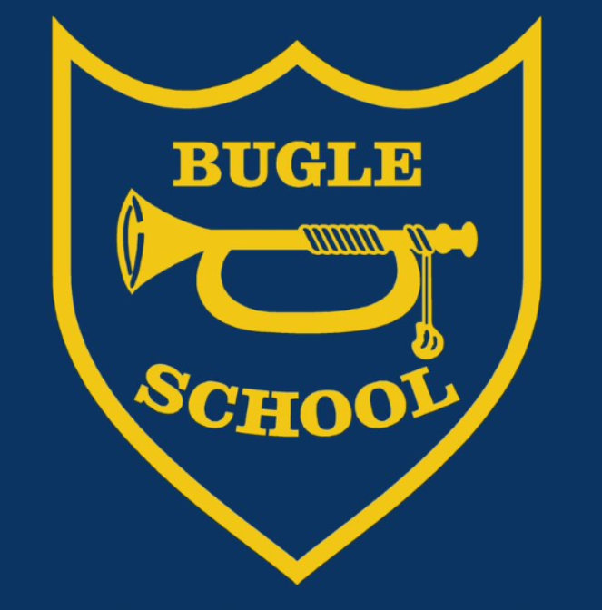


BUGLE SCHOOL

Behaviour and Achievement Policy

Aim of the School:

At Bugle School our aim is to promote a fully inclusive partnership (staff, parents, hub councillors and child) where there is true equality of opportunity in all aspects of life-long learning.

In order to achieve this aim we will raise:
- Self esteem and well being;
- Academic achievement;
- Awareness of personal responsibility and behaviour for learning and;
- An appreciation and understanding of difference.

Code of Behaviour

Our expectations are that all pupils will:
- Be polite, responsible and considerate to each other, to staff and any visitors.
- Look after and care for our grounds, buildings and equipment.
- Produce work to the best of their ability.
- Promote the good name of the school and feel secure as a valued member of a team.
- Take full advantage of the opportunities to learn.
- Not become involved in or tolerate bullying of any kind.
- Be punctual and walk quietly around the buildings and grounds.
- Never behave in a violent or threatening manner.
- Never swear or use abusive language.
- Wear school uniform.
- Respect themselves and other people.

3 core values are:

We expect the children to all follow the following 3 rules, both inside and outside of school:

-To be Ready to learn
-To Respect everyone and everything.
-To keep everyone Safe.

Behaviour and Achievement

In order to maintain high standards we expect that all staff, pupils and their parents make a positive contribution and take collective responsibility for maintaining high standards. All staff have received ‘Trauma and Mental Health Informed Schools’ training and use these methods to deescalate and investigate situations. This training will be part of any new staff induction.
It is an expectation that all members of staff, when dealing with incidents of poor behaviour, give all pupils involved the opportunity to explain what happened. No assumptions should be made and adequate time must be given to resolve the problem. Only then can the correct action be decided upon. We understand that unwanted behaviour is a form of communication and therefore dedicate time to understand what each child is trying to communicate and to support them in their emotional development and in finding more appropriate means of communicating this in the future.

Good Routines

Our expectations of good behaviour must be within the context of an orderly school day. It is essential that we consider each aspect of the children’s day.
This includes:
- The learning environment – tidy, interactive, stimulating and celebratory
- Classroom organisation – so that the basic needs are met and children can find what they need
- Routines for the school day – planned, understood by children, minimum fuss and time wasted
- Movement around the academy – quiet and calm
- Time keeping – lessons, playtimes, beginning and end of the day,
- Assemblies- a time for communal celebration and quiet reflection - children and adults to enter and leave silently

RWI Signals
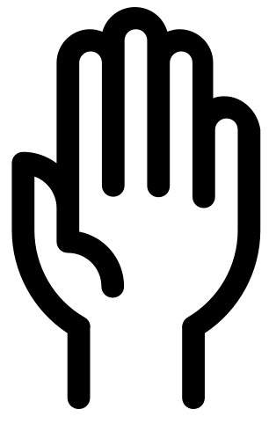
To provide a consistent approach to getting pupils attention, moving around the classroom and engaging in pupil discussion, we will all employ the following 3 silent signals.

-Team stop – a raised hand which the pupils mirror – verbal support might include: “Thank you Phillip and Martin. I am still waiting for 4 pupils to copy me.” This will be part of being ready to learn.
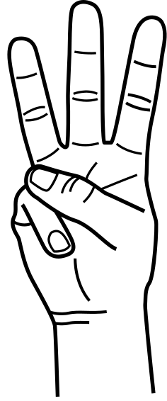
-1, 2, 3 – the 3 fingered silent signal will indicate 3 classroom routines that you want the children to complete silently. “On 1, stand up, 2, walk and stand behind your chair, 3 sit and fold your arms looking this way.”


-Turn to your partner – paired talk is an essential way to ensure all pupils are included. This essential feedback strategy will be used to ensure mass participation. Adults will circulate, initiate discussion and challenge thinking.

Responsibilities

All staff:

- Ensure that there are good routines (see above)
- Ensure that you are consistent, friendly and professional at all times.
- Remain calm.
- Aim to be positive at all times by seeking out and rewarding the good.
- Regularly discuss the 3 core values and why they are important.
- Explain that certain behaviours are not acceptable using the TIS approach.
- Be consistent with the use of sanctions and apply them fairly.

Playtime and Lunchtime staff

As above, plus
- Be active and engaging with the children.
- Be aware of the main problem areas (places, times and individual children.)
- Be active in your supervision.
- Return the children to class in a calm and orderly manner so that they are ready to learn.

Classroom staff

As above, plus
- Operate the school’s reward system
- Support playtime and lunchtime staff.

Senior Leadership Team

As for ‘All staff’, plus
- Support the staff in the implementation of the policy.
- Attend key meetings where required.
- Monitor the effectiveness of the policy through consultation with the key stakeholders and rigorous self-evaluation.
- Take prompt and decisive action to deal with areas for development.

Parents/Carers
- Encourage your child/ren to show positive behaviour
- Support the school to promote positive behaviour
- Engage with the rewards and sanctions system as needed
- Follow behaviour policy and processes, particularly those around suspension and reintegration

Bullying

We believe it is a basic entitlement of all pupils at Bugle School that they receive an education free from humiliation, oppression and abuse. Parents should feel entitled to feel confident that their children will be protected from bullies at school (see separate anti-bullying policy).

Behaviour for Learning System
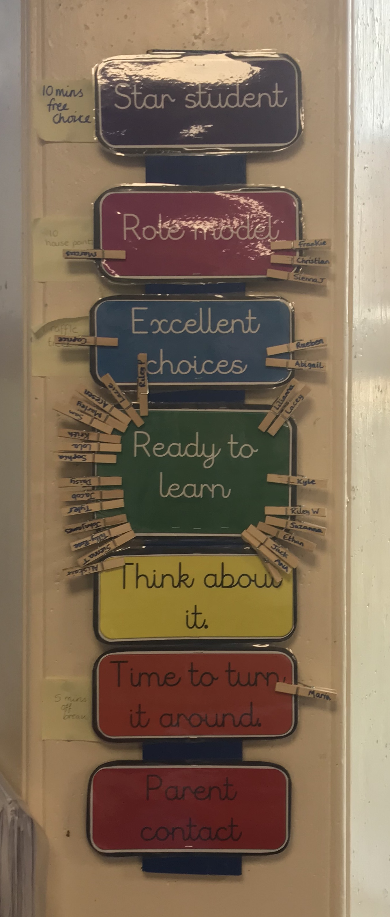
All classes will have displayed the school’s behaviour for learning ladder. All pupils start every day and every new session by showing the adults that they are ‘Ready to Learn’.

Being Ready has be categorised by the pupils and staff as:

Before school starts:
- Coming dressed in appropriate school uniform
- Being on time for school (arriving between 8.35 and 8:45am)
- Remembering to bring in their school reading book/homework.

In the classroom:
- Sitting on a chair/carpet correctly.
- Following the adult with their eyes to show you are listening.
- Looking after the equipment they have been given and ensuring it is out and ready for the lesson.
- Sticking in the LO, writing the correct date and underlining it.
- Getting on with their work immediately and quietly.

In the playground
- Lining up immediately after the whistle goes
- Walking in quietly, placing all items on their peg and returning to class.

Being Respectful has be categorised by the pupils and staff as:

In the classroom
- Not talking when others are.
- Being considerate and accepting of other classmates ideas, thoughts and feelings.
- Looking after equipment, not drawing on or marking the front of books.
In the playground
- Speaking in a way that is considerate of others thoughts, feelings and emotions.
- Looking after the equipment that has been provided
- Talking and listening to lunchtime staff requests
Moving around the school
- Pupils will walk on the left hand side of the corridor
- Pupils will walk silently to ensure that the learning of others is not disrupted.
- Ensuring that the corridors remain tidy by picking up coats, bags and other items that have fallen on the floor.

Being Safe has be categorised by the pupils and staff as:

In the school
- Moving round the school by walking only.
- Using computers correctly and following the schools E-Safety rules

In the playground
- Playing within the rules of the game and not making physical contact with others.
- Using equipment in the way it was intended

In the playground
The member of staff on duty is directly responsible for pupils’ behaviour. Class teachers are responsible for regularly discussing positive strategies and successful resolution ideas within classes. Pupils should be taught strategies for problems solving situations successfully.
Lunchtimes:
Lunchtime staff are responsible for monitoring the behaviours of children at all times.
Steps |  | Action
1 | Redirection | Pupils have reported that another child is being unkind to them. The adult investigates and speaks with all children involved. If a minor disagreement they will be asked to apologise and continue playing with their friends.
2 | Time out | If a pupil has admitted to, or been found to have failed to follow one of the school rules or being Ready, Respectful and Safe, they will be asked to serve a time out by sitting on a bench by an adult. The period of time will start at 5 minutes and increase to 15 minutes in 5 minute intervals.
3 | Taken out | If there is believed to have been any of the following, more serious incidents:  - Swearing,  - Deliberate Physical Contact  The pupil will be taken into school to a class teacher who is on duty (see Appendix A) who will deal with the incident and record it.  The sanctions may include: missing the remainder of their break and subsequent break times, a phone call to parents an meeting with SLT/Head of School.

Steps  The steps to managing pupil behaviour |  | Action
1 | Redirection | Gentle encouragement to change the unwanted behaviour to one that we expect to see. For example: “Well done to this table, you are listening and ready to learn. I can see that almost everyone is ready” At this point, pause and wait before continuing.  If the behaviour continues move to step 2.
2 | Reminder. | A reminder of the expectations Ready, Respectful, Safe delivered privately wherever possible. Repeat reminders if necessary. Continue to frame all language positively – “Remember, being respectful means looking at and listening to the adult whilst waiting your turn to talk, thank you.”  If the behaviour continues move to step 3.
3 | Caution | A clear verbal caution delivered privately wherever possible, making the learner aware of their behaviour. Clearly outlining the consequences if they continue but making it clear as to how they can turn this around. E.g. “Talking over an adult is not being respectful therefore I am moving your name down. I would like to see your eyes and ears this way, thank you.”
4 | Time with | Speak to the learner privately for 5-10 minutes during their break or lunch time and give them a final opportunity to modify their behaviour.  It is imperative that this is conducted with the class teacher. Discussions with the pupil should centre around why they chose to behave that way, a discussion about how they should be behaving and whether there is anything we can do to help them. This is also a time for children to silently reflect, following the discussion. The time missed needs to start following the discussion.  If the behaviour continues move to step 5
5 | Phone call  (Class teacher) | Should the learner persist with the unwanted behaviour or if the same pupil has had ‘time with’ 2 or more times in a day. A phone call home to is to be made to make parents/carers aware of the behaviours being seen at school. These behaviours should be logged using MyConcern with the behaviour tab selected. Please ensure that the location of the behaviour is identified to allow leaders to isolate ‘hot spots.’ SLT may be involved
6 | Formal Meeting | A meeting with the pupil, parents, teacher, SENDCo and Head of School to take place (and be recorded) if there is no noticeable change in behaviour after the phone call home or the child has had 4 or more ‘time with’ in 1 week. A behaviour plan will be implemented and monitored.
Exception  Immediate response |  | When certain gross misbehaviour has occurred towards pupils and adults, an immediate response is necessary, such as:-  - Serious fighting  - Bullying  - Derogatory behaviour such as racist, homophobic or non-inclusive  - Bad language directed at an adult  - Persistent defiance for a prolonged period of time  - Damaging property  - Hurting others with deliberate intent  In these cases, the incident will immediately be reported to SLT and recorded/logged in MyConcern, and an appropriate sanction/action taken in consultation with SLT. A phone call home will automatically take place, ordinarily by a member of SLT. The behaviours will be explored and managed by the school’s leadership team, class teacher and SENDCo.

Sanctions

The Code of Behaviour provides the framework required to maintain a secure and stable learning environment at all times.

Pupils, staff and parents should clearly understand the consequences of pupils breaking the Code of Behaviour. We will try to avoid the use of group sanctions. We try to ensure that the children know exactly why they are being sanctioned and help them develop strategies to modify their behaviour.

There are a range of sanctions that may be invoked if the Code of Behaviour is broken:
- verbal reminder;
- staying in at playtime or lunchtime to complete unfinished work;
- home/school book or daily behaviour report card introduced in consultation with parents;
- parents will be required to see class teacher/headteacher;
- internal suspension;
- fixed term suspension;
- directed offsite provision;
- permanent exclusion.

Behaviour to be recorded on My Concern with the behaviour team tagged into the concern.

This will be monitored by the Head of School, Assistant Head of School and SENDCo and discussed in SLT.

Serious offences will be discussed with the teacher, Headteacher, and the child’s parent(s)/carer(s). The school has high expectations with regard to behaviour and will not fail to act in the case of serious breaches of the code. Parents will always be consulted over ongoing or significant behaviour issues, as it is they who are the child’s first and enduring teachers. As parents you play a crucial role in helping your child learn. Children achieve more when schools and parents work together.

Rewards

We believe that rewards are more effective than sanctions in promoting good behaviour and high achievement.

Class Dojo’s are awarded for:-
- Quality work;
- Outstanding effort or achievement;
- Good progress;
- Positive attitude or actions;
- Initiative.
- Random acts of kindness

Each Friday, at Achievement Assembly, we celebrate the success of individuals or groups who have worked particularly hard. The certificates will focus on the pupils who have been:
- Ready
- Respectful
- Safe

Dojo’s – children rewarded with certificates at intervals of 25. Class totals will be recorded and celebrated at the end of each week. The class with the most Dojo’s at the end of the half term will choose a reward (non-uniform day, movie afternoon etc).

Positive parent postcards – when appropriate, staff can choose to send a positive postcard to pupils who have excelled or set a great example to others.

Suspensions and Exclusions (general)

Only the Head of School has the power to suspend and/or exclude a child from the academy.
The Head of School may suspend a pupil for one or more fixed periods, for up to 45 days in any one academic year.

The Head of School may also exclude a pupil permanently. Before taking such a step, the Head of School will have taken advice from, as appropriate: Hub Councillors, Aspire Board, the Education Welfare Service, Educational Psychological Service and any other relevant professionals.

If the Head of School suspends a child, they will inform the parents immediately in writing, giving reasons for the exclusion. At the same time, the Head of School will make it clear to the parents that they can appeal against the decision to the Hub Council. The academy informs the parents how to make any such appeal.

The Head of School will inform the Local Authority (L.A.) and the Hub Council about any permanent exclusion. Any pupil suspended for 15 days or more in a term will be discussed at panel to ensure actions and responses are adequate and to seek support for mitigating the risk of further suspensions. The Hub Council itself cannot either exclude a child or extend the exclusion period made by the Head of School.

A child may be suspended or excluded from school by the Head of School for a number of reasons, and for anything from a half-day to permanently. Bugle School will adhere to the guidance ‘Exclusion from maintained schools, Academies and pupil referral units in England Sept 2012 which relates to:
• The Education Act 2002, as amended by the Education Act 2011;
• The School Discipline (Pupil Exclusions and Reviews) (England) Regulations 2012;
• Section 89 of The Education and Inspections Act 2006;
• The Education (Provision of Full-Time Education for Excluded Pupils) (England) Regulations 2007.

Fixed Term Suspensions

If a child’s behaviour shows no improvement after all available options to the Academy have been used and all the above procedures followed, then a child may be suspended for a fixed term.

A fixed term period can be for half a day, up to five days. The length of the fixed term suspension will be dependent upon the reasons for the suspension.

Reasons for fixed term suspensions may include persistent low level unacceptable behaviours as defined above, or one or more incidents of serious unacceptable behaviours as defined above. It is likely that a combination of the above will contribute to suspension.

Parents will be contacted immediately and invited to school to discuss the seriousness of their child’s actions and discuss the terms upon which the fixed term suspension must be followed. This will be provided in writing.

Parents will be invited to attend a re-integration meeting at school before the end of the period of fixed term suspension to discuss the terms under which the child will be re-integrated back into school and any steps required to facilitate this return (e.g. phased return, reduced timetable, modification to Individual Behaviour Plan, etc). This is a vital step in supporting a positive return to school and establishing a fresh start for the pupil and it is imperative this is supported by parents.

Permanent Exclusions

Permanent exclusion will only be used as a last resort after all other options and sources of advice and support have been exhausted, in response to
• a serious unacceptable breach, or persistent low-level breaches, of the school's behaviour policy; and,
• where allowing the pupil to remain in school would seriously harm the education or welfare of the pupil or others in the school.

Exclusions will not be imposed immediately, unless there is an immediate threat to the safety of others in the school.

If an exclusion is relating to an isolated incident, before deciding to exclude, Bugle School will ensure that:
- a thorough investigation has been carried out
- the child being considered for exclusion has been encouraged to give their version of events
- consideration is given to whether the incident may have been provoked, for example by bullying or by racial harassment
- a written record of actions taken and interviews with the child are kept
- an exclusion is only made where the evidence shows that the child was responsible for the incident.
If an exclusion is relating to persistent low-level breaches of the school's behaviour policy and/or where allowing the pupil to remain in school would seriously harm the education or welfare of the pupil or others in the school, before deciding to exclude, Bugle School will ensure that:
- a behaviour support plan has been in place for the pupil
- strategies for support have been explored and reasonable adjustments are in place to help the pupil manage their behaviour
- referrals to other agencies have been considered/made
- plans have been discussed with parents/carers
- records are kept showing steps taken on MyConcern/as part of a SEND chronology document

Updated October 2024

To be reviewed October 2025

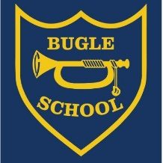

3 Core Values

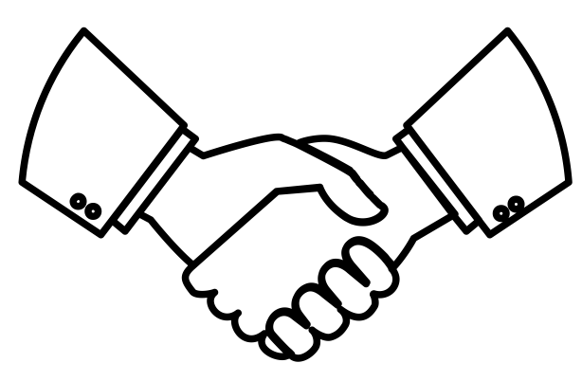
To respect everyone and everything in our school.

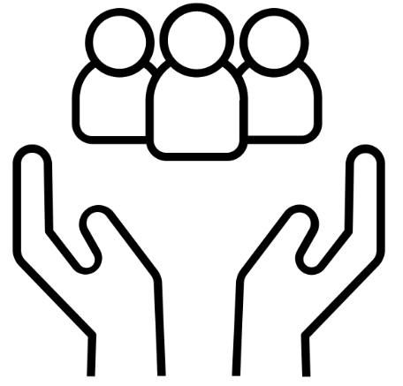
To keep everyone in our school safe.

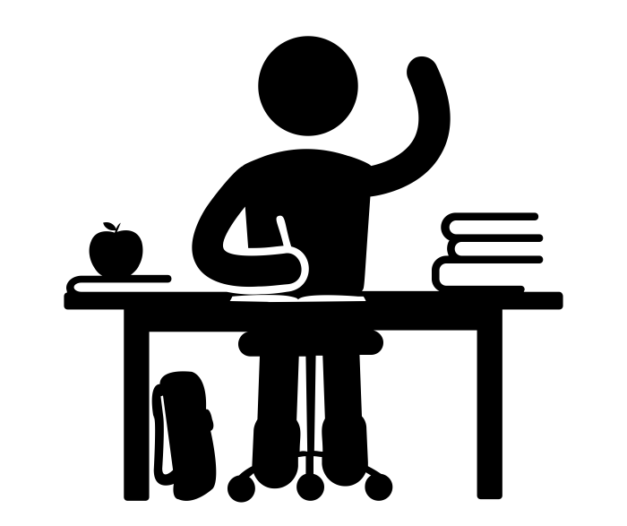

To be ready to learn.

