Bugle History Progression of Knowledge and Skills
Key Stage One
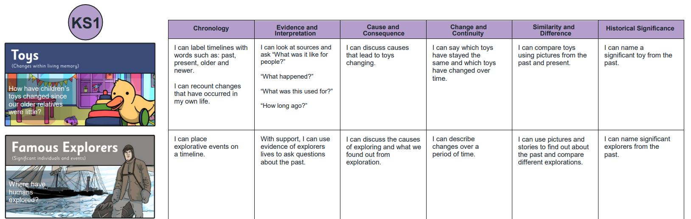
Core Knowledge
I know that toys and clothes have changed over time as new materials and processes have been invented.
Lesson One- How can we find out about the past? (Evidence and Interpretation)
I know that there are historical sources, like photos and videos, as well as talking to older people, that can help me find out about the past.
Lesson Two- What are our toys like now? (Historical Significance)
I know that modern toys are made using newer materials like plastic, which allows them to have a wide range of movements and ways to play.
Lesson Three- What was my favourite toy when I was a baby? (Change and Continuity)
I know that my favourite toy has changed as I have become older and a photo of it can help me to remember a different time.
Lesson Four- What were our guardians toys like and how do we know? (Chronology)
I know that toys have changed since my guardians were young.
Lesson Five- What were our older relatives toys like and how do we know? (Chronology/Cause and Consequence)
I know that there were different toys in the past and some photos or toys have remained.
Lesson Six- How have toys changed since our older relatives were little? (Similarity and Difference)
I know that the materials used in toys have changed since my older relatives were young.
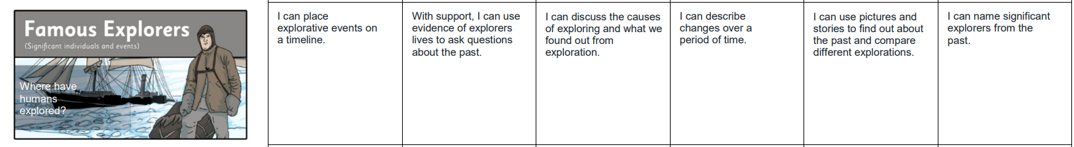
Core Knowledge
I know that key individuals, including Charles Darwin and Neil Armstrong, have had a huge impact on everyone in the world through exploration.
Lesson One- How can we find out about the past? (Evidence and Interpretation)
I know that sources, such as pictures, can help me to explore the past.
Lesson Two- Why do people explore? (Cause and Consequence)
I know people have explored in different ways, such as ships to submarines, as technology has changed over time.
Lesson Three- Who are the important explorers of the past? (Historical Significance)
I know that people can have such a huge impact, they are remembered today through statues and memorial days.
Lesson Four- What are the famous explorations of the past? (Chronology)
I know that significant explorations have developed and become more ambitious over time.
Lesson Five- Can we compare different explorations? (Similarity and Difference)
I know that whilst technology used for exploration has changed over time, there are key themes in explorers across history.
Lesson Six- How have explorations changed over time? (Change and Continuity)
I know that humans have used advancing technology to explore more inhospitable parts of our plant and beyond.
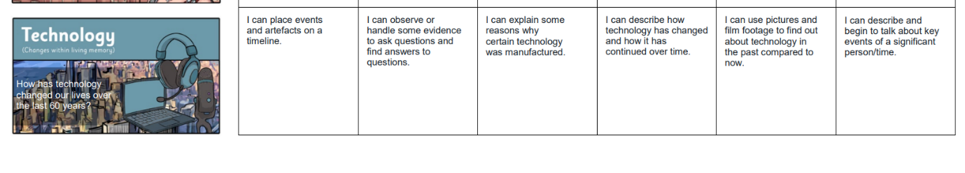
Core Knowledge
I know that technology has changed over the past 60 years. I know what the term technology means and how we use it in our everyday lives.

Lesson One: How can we find out about the past? (Evidence and Interpretation)
I know that technology use to be different than what it is now.
Lesson Two: How has technology changed how we write? (Historical Significance)
I know that I can communicate differently now than in the past (typewriter).
Lesson Three: How has technology changed how we talk? (Change and Continuity)
I know that telephones have changed over time and the differences between them.
Lesson Four: How has technology changed how we are entertained? (Chronology)
I know that television has changed and how. Thinking about channels and colour/black and white.
Lesson Five: Who are the important inventors in the history of technology? (Cause and Consequence)
I know the impact of Tim Berners-Lee on life today.
Lesson Six: How has technology changed our lives in the last 60 years? (Similarity and Difference)
I know the similarities and differences between technology and how it has changed over time.
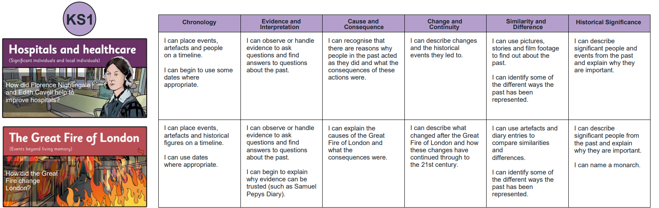
Core Knowledge
I know that women such as Florence Nightingale and Edith Cavell have had a significant impact on how hospitals and healthcare have changed over time.
Lesson One- How can we find out about the past? (Evidence and Interpretation)
I know that there are historical sources, like photos and videos that can help me find out about the past.
Lesson Two- Who was Florence Nightingale, and why was she important? (Historical Significance)
I know that Florence Nightingale is known as the ‘founder of modern nursing’.
Lesson Three- Who was Edith Cavell, and why was she important? (Historical Significance)
I know that Edith Cavell is a famous wartime nurse who helped soldiers no matter which side the fought on.
Lesson Four- When did Florence and Edith become significant? (Chronology)
I know that Florence became famous after the Crimean War whilst Edith became famous after World War One.
Lesson Five- Why did Florence and Edith act the way they did? (Cause and Consequence)
I know that Florence and Edith were compassionate people who showed others the importance of being this way.
Lesson Six- How has the past been represented? (Similarity and Difference)
I know that different sources can show similarities and differences between the past and now.
Lesson Seven- How did Florence and Edith change our hospitals? (Change and Continuity)
I know that Edith’s compassion was a model for the creation of the NHS and Florence modelled the attributes and professionalism now required of all nurses.

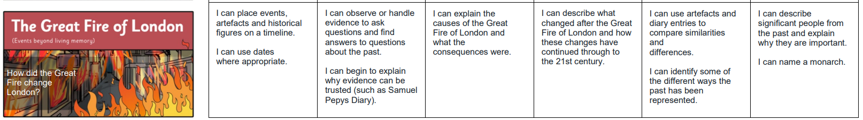

Core Knowledge:
I know how London has changed since the Great Fire of London. I can begin to know about Thomas Farriner, Samuel Pepys, King Charles II and Christopher Wren.
Lesson One: What was London like in 1666? (Evidence and Interpretation)
I know what London is like today (present) and using resources begin to know some differences.
Lesson Two: What happened on the 2nd September 1666? (Cause and Consequence)
I know how the fire started and why the fire started.
Lesson Three: How did the fire spread? (Historical Significance)
I know who Samuel Pepys is and his link to the Great Fire of London?
Lesson Four: What was left of London? (Evidence and Interpretation)
I know how much of London was destroyed looking at maps and picture evidence found by archaeologist.
Lesson Five: How was London rebuilt? (Similarity & Difference)
I know the roll of King Charles II and how London can change to be safer. I know Sir Christopher Wren.
Lesson Six: How did the fire impact the future? (Chronology & Historical Significance)
I know how London was impacted by the fire and the positive outcomes that have come out of it.
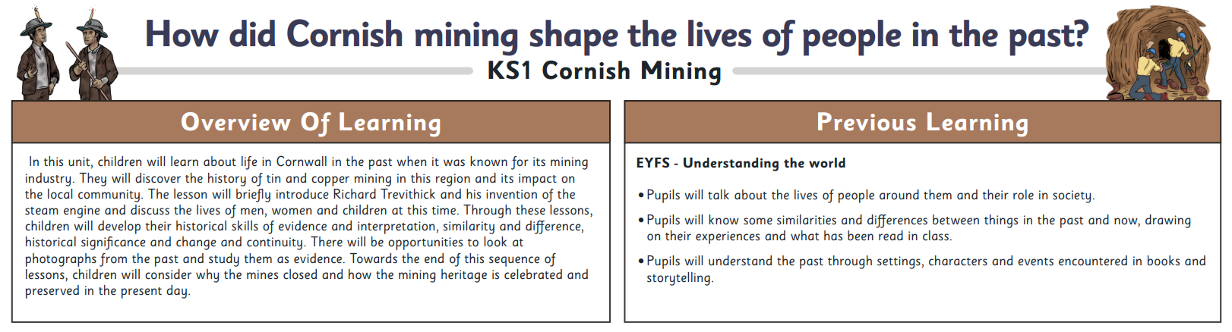
Core Knowledge
I know that Cornwall was a world leader in mining technology and skill with Cornish miners moving around the globe.
Lesson One- How can we find out about the past? (Evidence and Interpretation)
I know that there are historical sources, like photos and videos that can help me find out about the past.
Lesson Two- Why was mining important in Cornwall? (Historical Significance)
I know that Cornwall became wealthy from its reserves of tin and China clay.
Lesson Three- What was life like for people in Cornwall in the past? (Similarity and Difference)
I know that Edith Cavell is a famous wartime nurse who helped soldiers no matter which side the fought on.
Lesson Four- How has Cornish mining been celebrated and preserved today? (Change and Continuity)
I know that Florence became famous after the Crimean War whilst Edith became famous after World War One.
Lesson Five- Why did Florence and Edith act the way they did? (Cause and Consequence)
I know that Florence and Edith were compassionate people who showed others the importance of being this way.
Lesson Six- How has the past been represented? (Similarity and Difference)
I know that different sources can show similarities and differences between the past and now.

Key Stage Two
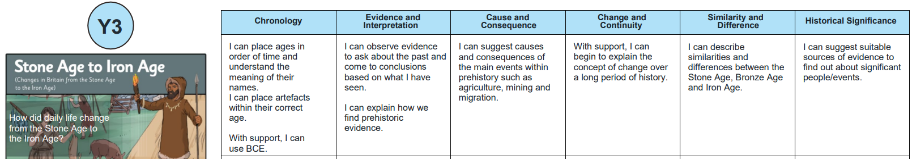
Core Knowledge:
I know that daily life changed from the stone Age to the Iron Age.
What was life like in the Paleolithic and Mesolithic?
Lesson One: What was life like in the Paleolithic and Mesolithic? (Evidence and Interpretation)
Lesson Two: What changed from the Paleolithic to the Mesolithic? (Change and Continuity)
Lesson Three: What did people eat in the Paleolithic and Mesolithic? (Evidence and Interpretation)
What key changes took place from the Neolithic to the Bronze Age?
Lesson Four: How did the search for food change in the Neolithic? (Change and Continuity)
Lesson Five: What tools were used in the Neolithic? Historical significance. (Change and Continuity)
Lesson Six: Who were the beaker people? (Historical significance)
Lesson Seven: How did tools change after the Neolithic? (Cause and Consequence)
How did daily life change from the Stone Age to the Iron Age?
Lesson Eight: How did the Bronze Age move into the Iron Age? (Change and Continuity)
Lesson Nine: What are roundhouses? (Evidence and Interpretation)
Lesson Ten: What is a hillfort? (Evidence and Interpretation)
What was life like in the different regions of England during the Stone Age?
Lesson Eleven: What was life like in the different regions of England during the Stone Age? (Evidence and Interpretation)

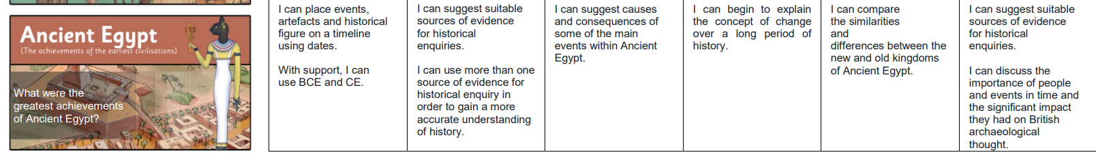
Core Knowledge:
I know that early civilisation started within Egypt. I know and I am about to talk about Egyptian gods, afterlife, pyramids and the greatest Pharaoh in Egypt’s History.
How did Early Egypt begin and what was it like there?
Lesson One: What is the chronology of Ancient Egypt? (Evidence and Interpretation)
Lesson Two: What was life like in early Egypt? (Evidence and Interpretation)
Lesson Three: Did the Ancient Egyptians write anything down? (Evidence and Interpretation)
How did Ancient Egypt change during the Old Kingdom?
Lesson Four: Who were the Egyptian gods? (Historical significance)
Lesson Five: What did the Ancient Egyptians believe about the afterlife? (Cause and consequence)
Lesson Six: How were the pyramids built? (Evidence and Interpretation)
What changes took place from the Old Kingdom up to the end of the Egyptian Empire?
Lesson Seven: What were the consequences of invasion on the Old Kingdom of Ancient Egypt? (Cause and consequence)
Lesson Eight: What were the successes of the New Kingdom? (Similarity and difference)
Lesson Nine: Who was Ramses II? (Historical significance)
Lesson Ten: How did the Egyptian Empire end? (Cause and consequence)

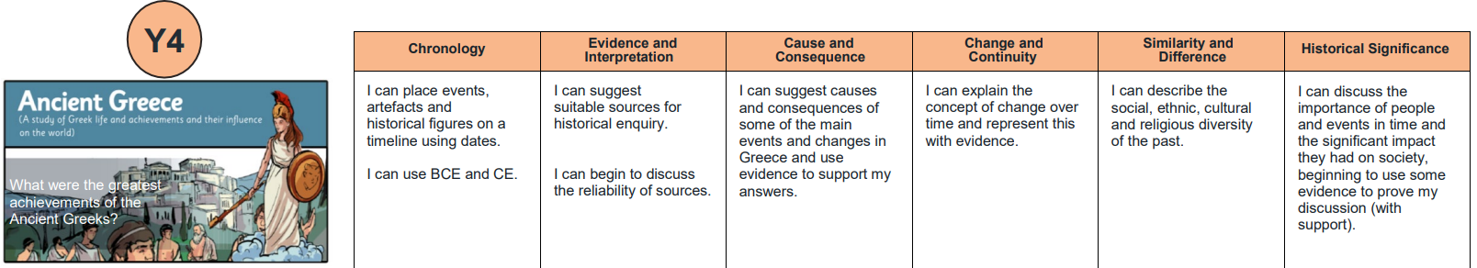

Core Knowledge:
I know the greatest achievements of Ancient Greeks. I know the leadership during this period and trade.

How did early Greece begin and what was it like there?
Lesson One: What can excavations tell us about early Greece? (Evidence and interpretation )
Lesson Two: What was life like in early Greece? ( Evidence and interpretation )
Lesson Three: How did the Minoans trade in early Greece? ( Evidence and interpretation )
What was life like in the city-states of Greece?
Lesson Four: What was life like in Athens and Sparta? ( Similarity and Difference )
Lesson Five: How did the citystates overcome the Persian invasion? ( Cause and consequence )
Lesson Six: What was life like in the city-states after the Persians retreated? (Historical Significance )
How did Alexander the Great expand Greek power and influence?
Lesson Seven: How did King Philip ll grow the Macedon Empire? ( Chronology )
Lesson Eight: Who was Alexander the Great and what made him a significant leader? ( Historical Significance )
Lesson Nine: What were the greatest achievements of Ancient Greece? ( Historical Significance )

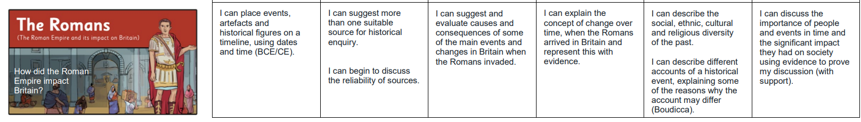
Core Knowledge:
I know that the Roman Empire was between 43CE and 410 CE. I know what life was like in early Rome. I know about Roman invasions. I know how the Romans protected new lands and about Boudicca.
How did early Rome grow to become the Roman Empire?
Lesson One: What do we know about early Rome and how do we know this? (Evidence and Interpretation)
Lesson Two: Who was in charge of the Roman Empire? (Chronology )
Lesson Three: How powerful was the Roman army? ( Historical significance)
How did the Britons resist occupation?
Lesson Four: What events led up to Emperor Claudius invading Britain? (Chronology )
Lesson Five: How did the Roman settlements compare to the Celtic villages? (Similarity and Difference)
Lesson Six: Who was Boudicca and why did she take revenge on the Romans? (Cause and Consequence)
How did the Roman Empire maintain control over Britain?
Lesson Seven: How did the Romans protect their land and how do we know this? (evidence and interpretation)
Lesson Eight: What happened in the final years of the Roman Empire? ( Change and continuity)
What was Roman life like in all nine regions of England?
Lesson Nine: What was life like in the different regions of England during the Roman era? (evidence and interpretation )

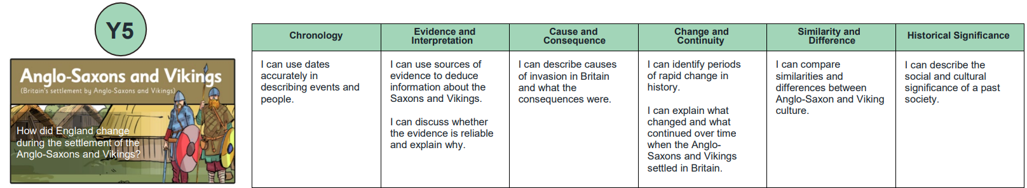
Core Knowledge
I know that the Anglo-Saxons and Vikings were two of the most successful invading people who changed Britain until the Norman Conquest in 1066.
Lesson One- What was life like in England at the end of the 4th Century? (Cause and Consequence)
I know that Rome was struggling to hold power in Britain due to the warring British tribes.
Lesson Two- How did life change in England after the fall of the Roman Empire? (Historical Significance)
I know that after the Romans left, British people warred and were invaded by many different people too.
Lesson Three- Why did the Angles, Saxons and Jutes settle in Britain? (Cause and Consequence)
I know that people settled in England to find better farming, new homes, to fight and because some were invited to defeat Celtic tribes.
Lesson Four- How was Anglo-Saxon Britain ruled? (Evidence and Interpretation)
I know that England was divided into seven Kingdoms and the Welsh and Cornish were pushed to the extremities of the island.
Lesson Five- How did the Anglo-Saxons keep control of their kingdoms? (Similarity and Difference)
I know war and money were important in maintaining control of a kingdom.
Lesson Six- What shifts in religion and power were there and how do we know this? (Change and Continuity)
I know that English Kingdoms had slowly converted to Christianity and Viking invasion challenged this rule.
Lesson Seven- Who were the Vikings and why did they carry out raids in Anglo-Saxon England? (Historical Significance)
I know that the Vikings were overseas raiders who came to England seeking gold, jewels and land.
Lesson Eight- Where did the Vikings settle and who was in control of England at the time? (Evidence and Interpretation)
I know the Vikings ended up controlling almost all of England and ruled it under ‘Danelaw’ but King Athelstan wrestled back control.

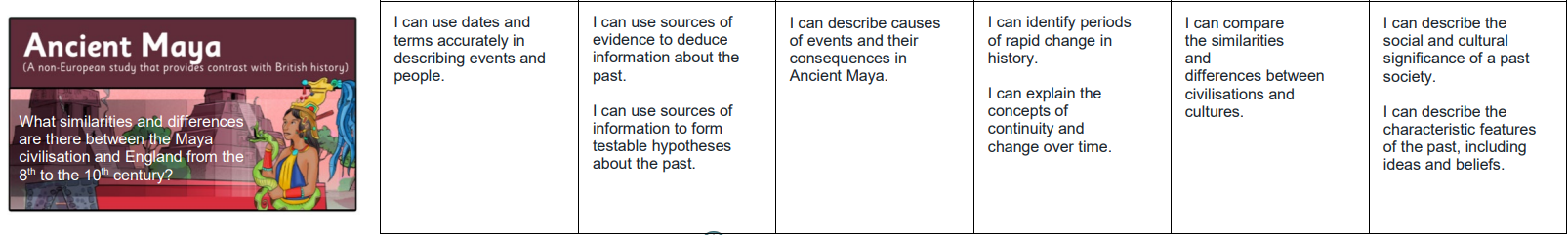
Core Knowledge:
I know who the Maya people were and where they lived in the world. I know why they were so successful.
How did the Maya rule in the Classic period?
Lesson One: Where and when did the Maya live? (Chronology)
Lesson Two: What made the Maya civilisation so successful? (Historical Significance)
Lesson Three: How do we know about the Maya? (Evidence and Interpretation)
Lesson Four: How were the Maya ruled? (Similarity and Difference )
How was the Maya region like England leading up to the 10th century?
Lesson Five: How was Anglo Saxon England ruled? (Historical Significance)
Lesson Six: What do we know about the Maya City States and the Anglo Saxon Kingdoms? (Evidence and Interpretation)
Lesson Seven: How do the leaders of the Maya and the Anglo-Saxons compare? (Similarity and Difference)
How do the shifting powers compare between the Maya region and Anglo-Saxon England?
Lesson Eight: How did the abandonment of the Southern Maya lowlands help the Northern city-states to thrive? (Historical Significance)
Lesson Nine: Who was involved in the struggle for power in England from the 8th to the10th century? (Cause and Consequence)

The Changing Power of the Monarchy- How has the monarchy changed since 1066?
Chronology- I can sequence significant monarchs of British history.
Evidence and Interpretation- I can use sources to ask and answer questions about the past, identifying change.
Cause and Consequence- I can suggest trends for the shifting power of monarchy.
Change and Continuity- I can compare the life of monarchs shortly after 1066 with monarchs after the English Civil War.
Similarity and Difference- I can compare similarities and differences between monarchs after 1066.
Historical Significance- I can describe the social and political changes that affected the role of the monarchy in Britain.

Core Knowledge
I know that the monarchy has adapted to changing values in society, slowly giving away powers as Britain transitioned into a democracy.
Lesson One- King John (Historical Significance)
I know that King John’s unpopularity over the loss of France led to the creation of Magna Carta which gave rights to all people (except peasants).
Lesson Two- King James I (Cause and Consequence)
I know that King James ruled both England and Scotland, oversaw the creation of a colony in North America and translated the bible (King James Bible). Guy Fawkes attempted to kill King James.
Lesson Three- King Charles I (Similarity and Difference)
I know that King Charles I’s refusal to let Parliament make too many decisions led to the English Civil War where Britain became a Republic.
Lesson Four- King Charles II (Similarity and Difference )
I know that King Charles II restored the monarchy, with less power than before, by being more popular than Oliver Cromwell. King Charles II was known as the ‘merry monarch’.
Lesson Five- King James II (Chronology)
I know that King James II’s unpopular rule led to our modern ‘Constitutional Monarchy’ we still have now, this limited a monarch’s freedoms.
Lesson Six- King William III and Queen Mary II (Evidence and Interpretation)
I know that William and Mary were the first monarchs to rule together, overseeing Britian’s first years as a ‘Constitutional Monarchy’.
Lesson Seven- Queen Anne (Change and Continuity)
I know that Queen Anne was the first monarch for all of Great Britian and started Britain’s ‘Golden Century’.
Lesson Eight- Queen Victoria (Historical Significance)
I know that Queen Victoria led Britain into industrialisation, a huge empire and greater wealth.
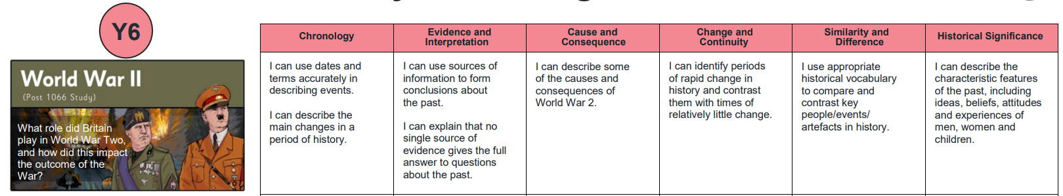
Core Knowledge
I know…
Lesson One- (Historical Skill)
I know…
Lesson Two- (Historical Skill)
I know…
Lesson Three- (Historical Skill)
I know…
Lesson Four- (Historical Skill)
I know…
Lesson Five- (Historical Skill)
I know…
Lesson Six- How have toys changed since our older relatives were little? (Historical Skill)
I know that the materials used in toys have changed since my older relatives were young.

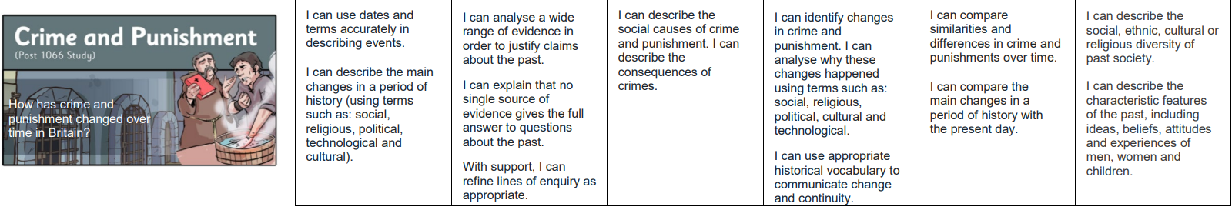
Core Knowledge
I know that punishments and crimes have changed over time, with the introduction of a police force and fairer laws.
Lesson One- What is crime and punishment? (Chronology)
I know…
Lesson Two- What was crime and punishment like in Roman Britain? (Historical Significance)
I know…
Lesson Three- What was crime and punishment like in Anglo-Saxon Britain? (Evidence and Interpretation)
I know…
Lesson Four- What was crime and punishment like in Tudor Britain? (Change and Continuity)
I know…
Lesson Five- What was crime and punishment like in the Stuart period? (Evidence and Interpretation)
I know…
Lesson Six- What was crime and punishment like in Georgian Britian? (Cause and Consequence)
I know…
Lesson Seven- What was crime and punishment like in Victorian Britain? (Evidence and Interpretation)
I know…
Lesson Eight- How did the police force develop through the 20th century? (Change and Continuity)
I know…
Lesson Nine- What are crime and punishments like today in comparison to the past? (Similarity and Difference)
I know…

